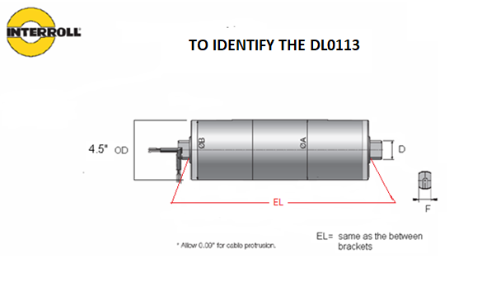
PLEASE CLEARLY IDENTIFY WITH EXACT MEASUREMENTS:
EL:
F:
D:
MATERIAL, SS OR MILD STEEL:
TUBE PROFILE, TRAP CROWN OR FLAT:
INPUT VOLTAGE AND HZ:
60HZ BELT SPEED:
STRAIGHT CABLE, SHAFT CAP SLOT, OR ELBOW:
REQUIRED BELT PULL:
CABLE LENGTH:
SERIAL NUMBER OR PART NUMBER IF AVAILABLE:
SPECIAL NOTES:

