PROCEDURE TO DETERMINE THE HEALTH OF A MOL MOTOR
(Testing is performed with an Ohm meter requiring someone familiar with its use and practices)

Winding Resistance Test
- Disconnect the incoming power lead from the Mol motor at the Molex connector (the capacitor must be disconnected for proper testing).
- Measure the resistance of the Primary winding (use the blue and black wires on the Molex connector). It must be in the range of 6.21-7.59 Ohms.
- Measure the resistance of the Secondary winding (use the red and yellow(white) wires on the Molex connector). It must be in the range of 12.06-14.74 Ohms.

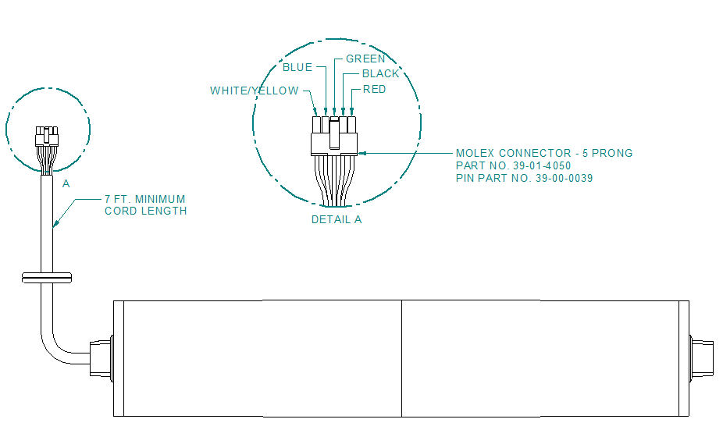

Winding Short Circuit Test
- Check the ground continuity of the Primary winding (use the black and green wires on the Molex connector). There should be no continuity (infinite resistance=open circuit).
- Check the ground continuity of the Primary winding (use the red and green wires on the Molex connector). There should be no continuity (infinite resistance=open circuit).
- Check the continuity between the Primary and Secondary windings. (use the red and black wires on the Molex connector). There should be no continuity (infinite resistance=open circuit).

If the winding resistances are outside of the Good range or if any continuity test is positive, the motor is bad and should be replaced.

